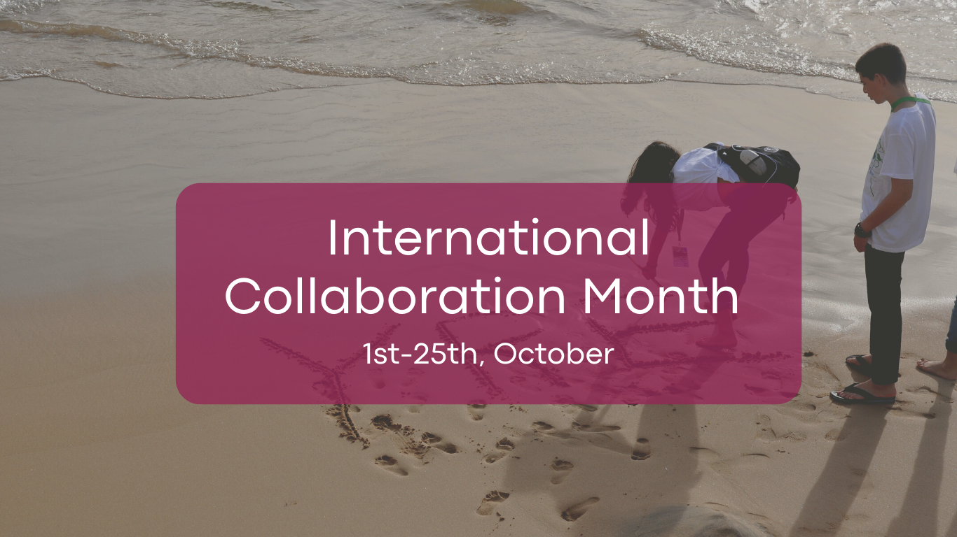

Dear schools, teachers, and students,
International Collaboration Month is now open to all countries in the YRE network! If you want to join the YRE competition program by collaborating with another country, this is a piece of news you can’t miss.
To know the structure of the YRE programme better, there are three ways to participate in the YRE International Competition:
- General YRE International Competition
- Litter Less Campaign Competition
- International Collaboration
International Collaboration is a special category and aims at encouraging teachers and students to collaborate and exchange information with those from other countries. We believe it will be a precious learning process for you to make a joint achievement from viewpoints/knowledge exchange and effective communication through your collaboration.
You can find more details here:
International Collaboration — Young Reporters for the Environment (yre.global)

You may wonder: How does one find a match?
It is very simple, if you are a school or a teacher who wants to participate with your students via the international collaboration, fill in the following form. If you are a student, please ask your teacher and/or your National Operator to register. The validation of your registration will be done by the NO of your country, and the FEE International Team will match schools and let you know about it at the beginning of November! This form is enabled from the 1st to the 25th of October:
YRE Collaboration 2022-23 (google.com)

You are interested but need inspiration on how to start? Find it from these winning examples from 2022
1st Place
Title: WILDFIRES & CLIMATE CHANGE A fiery summer for Turkey and Greece
Countries: Greece & Turkey
Honourable Mention
Title: Change for The Worse: Forest Fires in Turkey and Frost in Slovenia
Countries: Slovenia & Turkey

