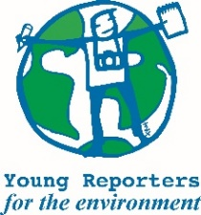
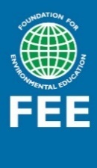
Campaign ideas for Young Reporters for the Environment 2020/21
- COVID-19 response

#YREStayActive
This campaign is designed for students that are facing COVID-19 challenges. The idea is to keep students involved in environment-focused citizen journalism that encourages them to investigate local environmental issues and solutions. For the coming school year FEE is planning about 3-4 campaigns for YRE and each campaign will be run for two months.

Similar campaigns will also be implemented by Eco-Schools and LEAF programmes but will adapt to objectives and relevant skills of each of the programme.

Four campaigns in total (examples):

1. Water Sanitation and Hygiene (WASH)
Connection with Health and Wellbeing theme through WASH behaviours, building immunity, mental wellbeing, etc.

2. Waste Management and Littering
Disposable protective materials like masks and gloves have created a new stream of hazardous waste. As more time is spent at home, there is an opportunity to extend this activity to sustainable consumption and involve the family in making choices to reduce waste in the bin.

3. Health and Nutrition/Well-Being
In many communities, schools also fulfil the supplementary nutritional needs of the children. Engaging children to report on growing their food in small pots, home backyards, and community spaces could be an interesting activity that may not only supplement food but also create an appreciation for the food and hence reduce waste.

4. Biodiversity
Report on local biodiversity challenges.

We are proposing campaigns around the above themes as easy-to-do activities during the next academic year. The campaigns need to encourage students to investigate ad report on local environmental issues and solutions.

Participate in the challenges and contribute to YRE activities for the current academic year
Weekly challenges:
At the end of the campaign, each country should submit the best stories. The best stories should be linked to the YRE 4-steps and presented through:
- Text of max. 200 words including the description of the activities and reflection
- Min. 1 photo / photo story of 3-5 photos
- Or a video up to 1 min

Weekly challenges will be published on social media for inspiration. National Operators can select them and share with the network of schools. Activities organised by students from home can be shared on social media with the #YREStayActive hashtag and National Operators and the International team can share it on their social media.

1. Water Sanitation and Hygiene (WASH)
Connection with Health and Wellbeing theme through WaSH behaviours, building immunity, mental wellbeing, etc.

Ideas for activities:
- Find ways to promote positive hygiene behaviours and document any behaviour change in your community through a short video or photo series.

- Distinguish key hygiene behaviours needed in your community and conduct a survey to find out to which extent these behaviours are being implemented. Present your findings through a short video, podcast or photo series.

- Record an (online) interview with a local politician/expert on what challenges your community is facing concerning sanitation (e.g. infectious waste, access to clean water etc).

- Interview students from other YRE countries on challenges related to Water Sanitation and Hygiene (WASH)
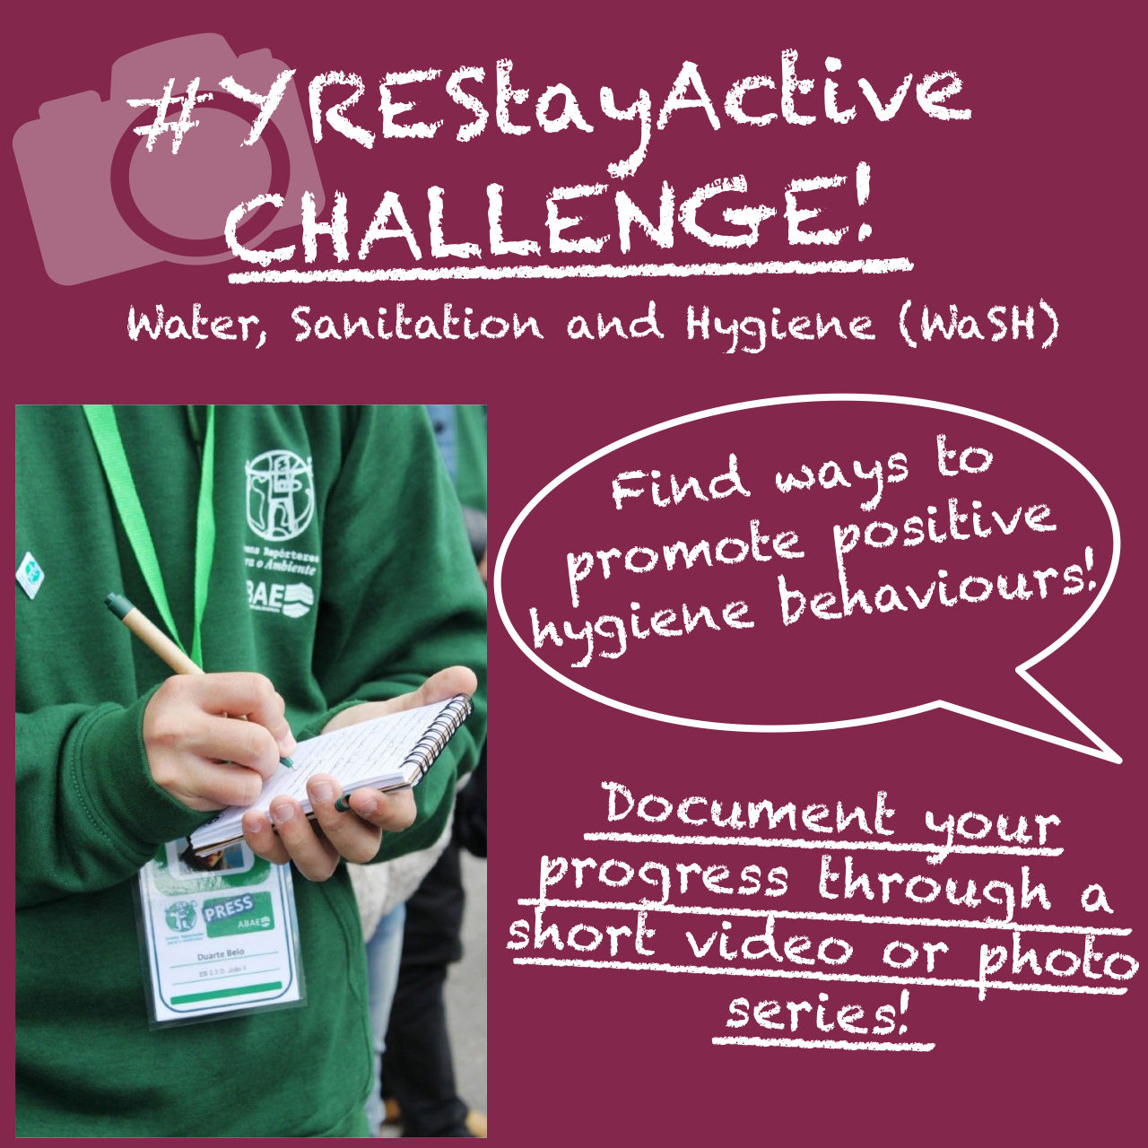
Post for social media:

(Add further details in
description of post)

The best stories from countries will be submitted by National Operators on Podio after each of the campaign ends. Remember that it can be a short story with photos or a video.

The submission must:
- Be in English (or translated/subtitled)
- Have been published on national or international social media using the hashtag #YREStayActive
- Highlight a topic relevant to this campaign
- Be sent to YRE International no longer than a week after the campaign has ended.

Finding the winners:
All nominees will be presented to the YRE National Operators who will give points to the ones they believe are the best. To ensure fairness, they are not allowed to vote for stories from their own countries.
The winners of the campaign will receive diplomas from YRE International, mention on social media & website and a prize.

Online meetings and webinars:
Each campaign will be introduced to the participants through the webinar. During the first webinar, the experts will present WaSH rules and ideas for schools (teachers and students).
More about webinars and registration can be found here https://www.yre.global/webinars

